Individual reflection report (Yap Aik Shen J19029478):
GTP 1
INDIVIDUAL /SELF REFLECTION REPORT (5%) & PEER REVIEW (5%)
ON EMPLOYER PROJECT WITH BOOK DOC

Think about what you did in this project (your tasks and responsibilities), and how well did the project went for your team.
Write your reflection in the right column.
1000-1200 words
PART A: SELF REFLECTION
Fill up your Answer INSIDE the below Table/Template
Student Name: | Yap Aik Shen
Student ID: | J19029478
Section : | DB5
Group/Team Name: | The Optimizers 2.0
Role in Team : | Secretary
All the evidences of the points of Individual reflection & peer review are provided here :

https://docs.google.com/document/d/1BJbrtrVCNIXVWQVQHsKjcJQymtt9ZCVK8MAtIAuzU6g/edit?usp=sharing
List the Part (s) you in charge of : | GTP1 :  1) Q1 : P1, half of P2. P5  2) Q2 : P1, P2, P6, P8  3) Q5 : small part of P4 (4th Competitor)  4) Q6 : P2
About Myself: | Explain and provide evidence
1. What personal strengths / weaknesses of mine did this project reveal? | GTP1 :  - Time management – I did not utilize my time efficiently as there are a lot of other assignments.  - Cooperative – being cooperative with the group members to do my works on time  - Lack of confidence (weakness)- It took me more time to finish the task as I were not confident enough about the points written.
2. How did my strengths or weaknesses affect the task that was given to me, positively and negatively? | GTP1 :  - Time management – negatively affect my work as I did not utilize the time.  - Cooperative – positively increase my working efficiency  - Lack of confidence affects the task that was given to me negatively as it takes me more time to do an easy task.
3. What can I do to build about my strength and overcome my weaknesses? | GTP1 :  - Cooperative – take note on what lecturer and group leader advises on dateline of each task  - Time management – do a time schedule for the work.  Lack of confidence – find confidence through motivation videos
4. What did I experience in terms of difficulty working/ interacting with other people? | GTP1 :  - Communication – we were having virtual communication such as virtual meeting which is not that efficient  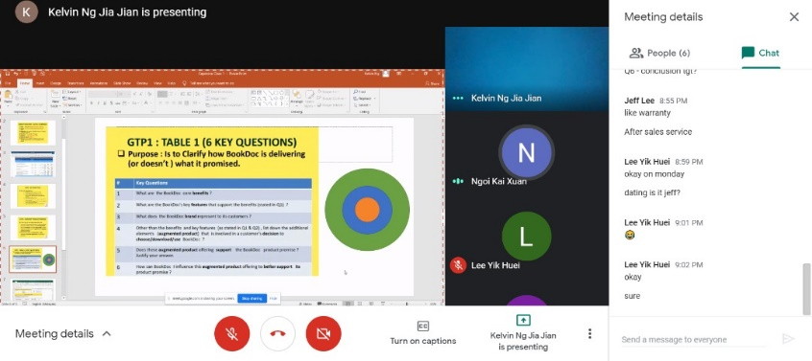  - Cooperation – there would be sometime when the group members did not aware about the notification of the task  - Arguments on ideas – we have a lot of ideas so it causes arguments when discussing
5. What can I do differently next time to minimize such difficulties? | GTP1 :  - Having more communication methods – I will try to have more communication methods with other group members  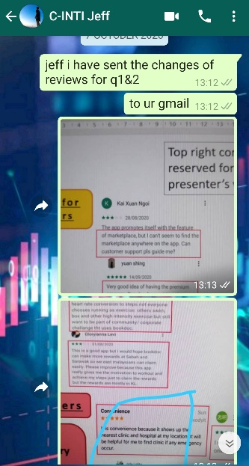  - Reminds earlier – I will try to remind the group members about the notification  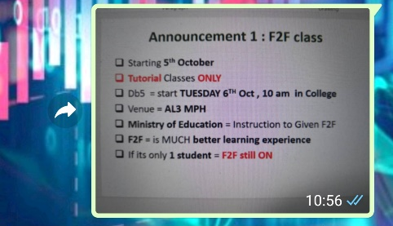  - Review the ideas – review the ideas provided by the other group members  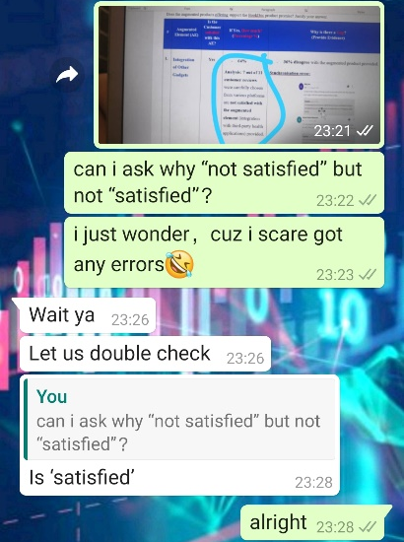
6. What personal skills did I use in handling my task? | GTP1 :  - Analytical skill – analyze the points from internet  - Hard skill – using Microsoft Word & Excel  - Problem solving skill – change and improve the points depends on lecturer’s checklist
7. What personal skills would I like to have had in order to have handled it better and how might I develop them? | GTP1 :  - Ability to work under pressure – I need to have the ability to complete my task on time while doing other assignments also  - Confidence – be confidence for the ideas  - Creativity – provide more creative ideas for the task
About Project:
1. What I enjoyed: (write about what you liked most about the project) | GTP1 :  - Teamwork – we have instant virtual meetings to discuss and delegate the tasks clearly and every team member has performed well under the instructions given by the leader.  - Learning new things – Through the project, I’ve learned that the business model, product promise and core benefits & features of BookDoc app.  - Find out business opportunities – Through the project, it gives me some creative business ideas to start my own business after graduating.  - Find out improvements of app – I’m enjoying to give some suggestions on improvements of the app to employer (BookDoc) so that it can really benefit the users with their product promises.
2. What I found difficult: (write about any part of the project you found hard to do.) | GTP1 :  - To provide creative ideas- While doing GTP1, I found that it takes time to do research on finding creative ideas.  - Shortage of time – I feel rushed while doing the tasks of GTP1 as the time given by the lecturer was not so enough.  - Limited information on Internet – Some of the information about BookDoc app were hard to find such as the feature of marketplace and health coach because they are only accessible through premium account.  - Communication – Due to the covid-19 pandemic, we are doing capstone project through online class. So, it takes more time and times for us to discuss without seeing each others of the group members.
3. What really worked: (write about any part that you thought worked well). | GTP1 :  - As a secretary of the group, I have provided recordings of every group meeting including group meeting with lecturer. I believe this can really help the team members to revise of the important points and make improvement.  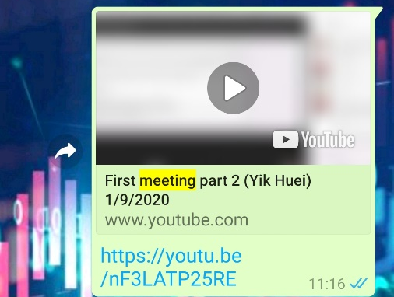  - As a secretary of the group, I’m doing my duty to edit & upload the Group Meeting Minutes to BB.  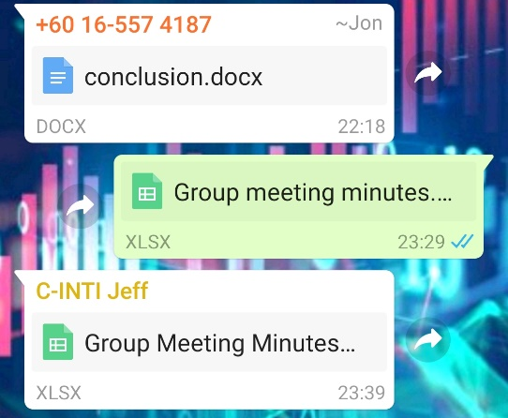  - Helping the team to provide & elaborate points – As the top of part of individual reflection that I provided, I’ve involved in doing Q1, Q2, Q5, Q6.  - The quality of work of GTP1 – Good quality of work that is ensured by Ms. Ihsan during draft check.
4. Next time: (write what you would do differently next time). | GTP1 :  - Provides more creative ideas – to help the group to score higher marks  - Improve the quality of the group project – I’ll make sure that what I do for my parts is forcing the lecturers to give full marks.  - Time management – I’ll manage my time efficiently so that it is enough time for me to provide good quality of points.  - Do things smartly – I’ll make sure to follow the tips and instructions provided by the lecturers before started to do the project.
5. How could your lecturer change this project to make it better next time? | GTP1 :  - Lecturers should provide a visit for us to visit BookDoc company so that we can have better understanding.  - Lecturers should make an arrangement for us to have a meeting with employer (BookDoc) so that we can have better understanding.  - Lecturers should discuss with the employer to give a free trial membership of premium account to each group so that we can access more features and information.  - Lecturers should delegate more time to give comments on every draft check of every group so that each group can makes better changes earlier.

Midpoint presentation
INDIVIDUAL /SELF REFLECTION REPORT (5%) & PEER REVIEW (5%)
ON EMPLOYER PROJECT WITH BOOK DOC

Think about what you did in this project (your tasks and responsibilities), and how well did the project went for your team.
Write your reflection in the right column.
1000-1200 words
PART A: SELF REFLECTION
Fill up your Answer INSIDE the below Table/Template
Student Name: | Yap Aik Shen
Student ID: | J19029478
Section : | DB5
Group/Team Name: | The Optimizers 2.0
Role in Team : | Secretary
All the evidences of the points of Individual reflection & peer review are provided here :

https://docs.google.com/document/d/1BJbrtrVCNIXVWQVQHsKjcJQymtt9ZCVK8MAtIAuzU6g/edit?usp=sharing
List the Part (s) you in charge of : | Midpoint presentation :  1) Q1 : content  2) Q2 : content  3) provide screenshots for Q1&Q2
About Myself: | Explain and provide evidence
1. What personal strengths / weaknesses of mine did this project reveal? | Midpoint presentation :  - Time management – I did not utilize my time efficiently as there are a lot of other assignments.  - Cooperative – being cooperative with the group members to do my works on time  - Lack of confidence (weakness)- It took me more time to finish the task as I were not confident enough about the points written.
2. How did my strengths or weaknesses affect the task that was given to me, positively and negatively? | Midpoint presentation :  - Time management – negatively affect my work as I did not utilize the time.  - Cooperative – positively increase my working efficiency  - Lack of confidence affects the task that was given to me negatively as it takes me more time to do an easy task.
3. What can I do to build about my strength and overcome my weaknesses? | Midpoint presentation :  - Cooperative – take note on what lecturer and group leader advises on dateline of each task  - Time management – do a time schedule for the work.  - Lack of confidence – find confidence through motivation videos
4. What did I experience in terms of difficulty working/ interacting with other people? | Midpoint presentation :  - Communication – we were having virtual communication such as virtual meeting which is not that efficient  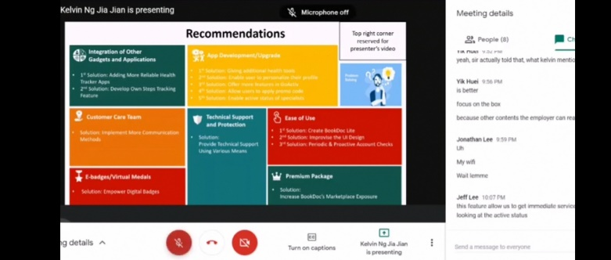  - Cooperation – there would be sometime when the group members did not aware about the notification of the task  - Arguments on ideas – we have a lot of ideas so it causes arguments when discussing
5. What can I do differently next time to minimize such difficulties? | Midpoint presentation :  - Having more communication methods – I will try to have more communication methods with other group members  - Reminds earlier – I will try to remind the group members about the notification  - Review the ideas – review the ideas provided by the other group members  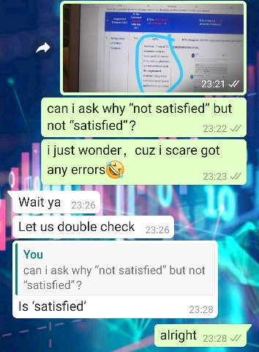
6. What personal skills did I use in handling my task? | Midpoint presentation :  - Analytical skill – analyze the points from internet  - Hard skill – using Microsoft Word & Excel  - Problem solving skill – change and improve the points depends on lecturer’s checklist
7. What personal skills would I like to have had in order to have handled it better and how might I develop them? | Midpoint presentation :  - Ability to work under pressure – I need to have the ability to complete my task on time while doing other assignments also  - Confidence – be confidence for the ideas  - Creativity – provide more creative ideas for the task
About Project:
1. What I enjoyed: (write about what you liked most about the project) | Midpoint presentation :  - Teamwork – we have instant virtual meetings to discuss and delegate the tasks clearly and every team member has performed well under the instructions given by the leader.  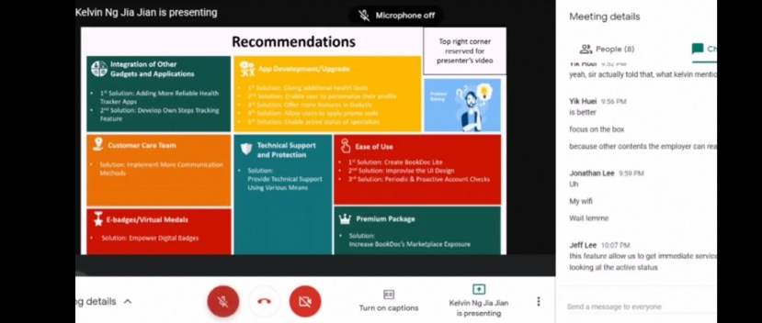  - Learning new things – Through the project, I’ve learned that what is the important part when designing slides.  - Summary skill – I have learned to simplify the points for the midpoint slides.
2. What I found difficult: (write about any part of the project you found hard to do.) | Midpoint presentation :  - To summarise the point- While doing midpoint slides, I found that it takes time to simplify the points for the slides.  - Shortage of time – I feel rushed while doing the tasks of Midpoint slides as the time given by the lecturer was not so enough.  - Limited information on Internet – Some of the information about BookDoc app were hard to find such as the feature of marketplace and health coach because they are only accessible through premium account.  - Communication – Due to the covid-19 pandemic, we are doing capstone project through online class. So, it takes more time and times for us to discuss without seeing each others of the group members.
3. What really worked: (write about any part that you thought worked well). | Midpoint presentation :  - As a secretary of the group, I have provided recordings of every group meeting including group meeting with lecturer. I believe this can really help the team members to revise of the important points and make improvement.  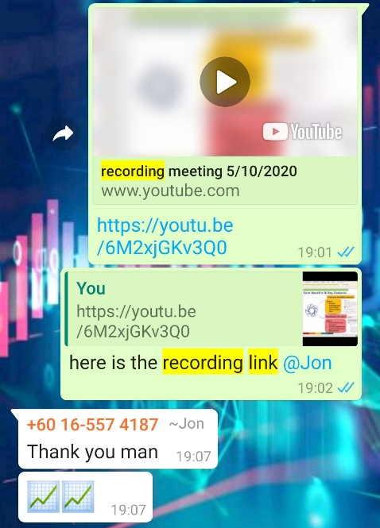  - As a secretary of the group, I’m doing my duty to edit & upload the Group Meeting Minutes to BB.  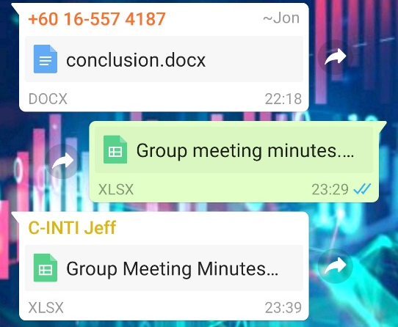  - Helping the team to provide & elaborate points – As the top of part of individual reflection that I provided, I’ve involved in doing Q1, Q2, Q5, Q6.  - The quality of work of Midpoint slides – Good quality of work that is ensured by Ms. Ihsan during draft check.  - I always provide screenshot of the contents of the class  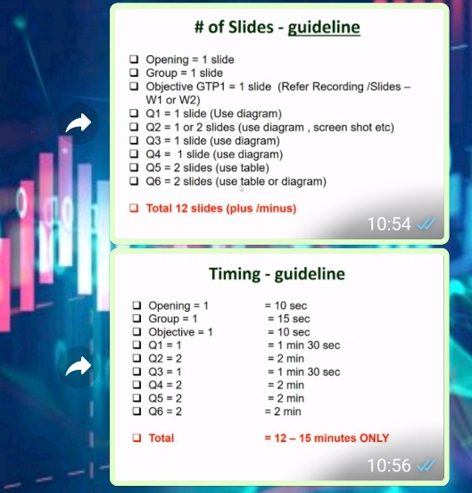  - Participating in rehearsal  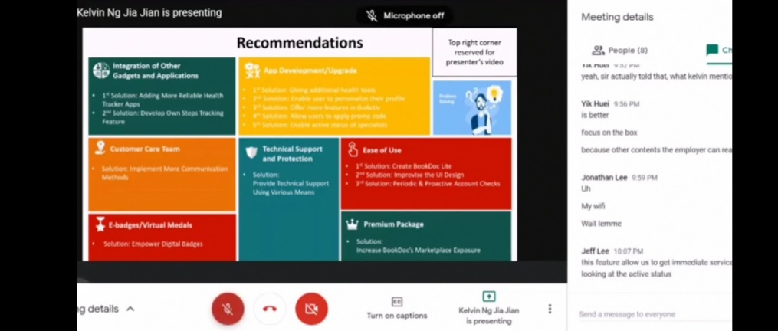
4. Next time: (write what you would do differently next time). | Midpoint presentation :  - Provides more creative ideas – to help the group to score higher marks  - Improve the quality of the group project – I’ll make sure that what I do for my parts is forcing the lecturers to give full marks.  - Time management – I’ll manage my time efficiently so that it is enough time for me to provide good quality of points.  - Do things smartly – I’ll make sure to follow the tips and instructions provided by the lecturers before started to do the project.
5. How could your lecturer change this project to make it better next time? | Midpoint presentation :  - Lecturer should check our midpoint presentation slides earlier instead of before submission.

GTP2
INDIVIDUAL /SELF REFLECTION REPORT (5%) & PEER REVIEW (5%)
ON EMPLOYER PROJECT WITH BOOK DOC

Think about what you did in this project (your tasks and responsibilities), and how well did the project went for your team.
Write your reflection in the right column.
1000-1200 words
PART A: SELF REFLECTION
Fill up your Answer INSIDE the below Table/Template
Student Name: | Yap Aik Shen
Student ID: | J19029478
Section : | DB5
Group/Team Name: | The Optimizers 2.0
Role in Team : | Secretary
All the evidences of the points of Individual reflection & peer review are provided here :

https://docs.google.com/document/d/1BJbrtrVCNIXVWQVQHsKjcJQymtt9ZCVK8MAtIAuzU6g/edit?usp=sharing
List the Part (s) you in charge of : | GTP2 :  1) Food Log
About Myself: | Explain and provide evidence
1. What personal strengths / weaknesses of mine did this project reveal? | GTP2 :  - Cooperative (strength)– being cooperative with the group members to do my works on time  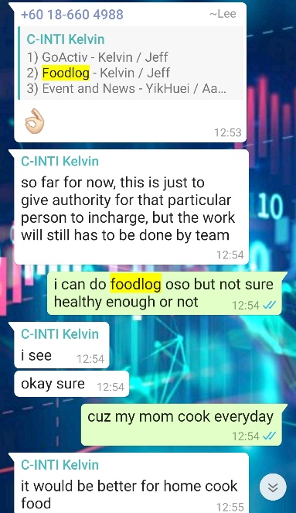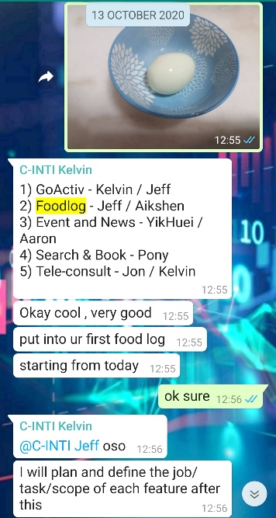  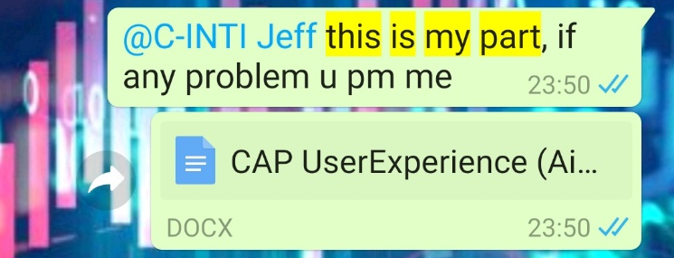  - Time management (weakness)– I did not utilize my time efficiently as there are a lot of other assignments.  - Lack of confidence (weakness)- It took me more time to finish the task as I were not confident enough about the points written.  - Too relax (weakness)- I started to do the task around the due date.
2. How did my strengths or weaknesses affect the task that was given to me, positively and negatively? | GTP2 :  - Cooperative – positively increase my working efficiency  - Time management – negatively affect my work as I did not utilize the time efficiently.  - Lack of confidence affects the task that was given to me negatively as it takes me more time to do an easy task.
3. What can I do to build about my strength and overcome my weaknesses? | GTP2 :  - Cooperative – take note on what lecturer and group leader advises on dateline of each task  - Time management – do a time schedule for the work and avoid last minute works.  Lack of confidence – find confidence through motivation videos
4. What did I experience in terms of difficulty working/ interacting with other people? | GTP2 :  - Communication – we were having virtual communication such as virtual meeting which is not that efficient  - 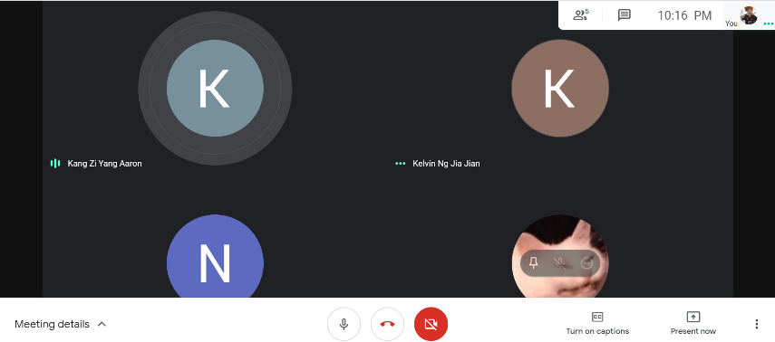  - Cooperation – there would be sometime when the group members did not aware about the notification of the task  - Arguments on ideas – we have a lot of ideas so it causes arguments when discussing
5. What can I do differently next time to minimize such difficulties? | GTP2 :  - Having more communication methods – I will try to have more communication methods with other group members  - Reminds earlier – I will try to remind the group members about the notification of date line.  - Review the ideas – review the ideas provided by the other group members
6. What personal skills did I use in handling my task? | GTP2 :  - Analytical skill – use and experience the competitors’ apps  - Hard skill – using Microsoft Word & Excel  - Problem solving skill – change and improve the points depends on lecturer’s checklist
7. What personal skills would I like to have had in order to have handled it better and how might I develop them? | GTP2 :  - Ability to work under pressure – I need to have the ability to complete my task on time while doing other assignments also  - Confidence – be confidence for the ideas  - Creativity – provide more creative suggestions for GTP2
About Project:
1. What I enjoyed: (write about what you liked most about the project) | GTP2 :  - Teamwork – we have instant virtual meetings to discuss and delegate the tasks clearly and every team member has performed well under the instructions given by the leader.  - Learning new things – Through the project, I have learned that there is barcode scanning function for food log in other competitors’ apps.  - Find out business opportunities – Through the project, it gives me some creative business ideas to start my own business after graduating.  - Find out improvements of app – I’m enjoying to give some suggestions on improvements of Food Log feature to employer (BookDoc) so that it can really benefit the users.
2. What I found difficult: (write about any part of the project you found hard to do.) | GTP2 :  - To provide creative suggestions- While doing GTP2, I found that it takes time to do research on finding creative suggestions about its competitors.  - Shortage of time – I feel rushed while doing the tasks of GTP2 as the time given by the lecturer was not so enough.  - Time-consuming – I found that finding and using the competitors apps are very time-consuming.  - Communication – Due to the covid-19 pandemic, we are doing capstone project through online class. So, it takes more time and times for us to discuss without seeing each others of the group members.
3. What really worked: (write about any part that you thought worked well). | GTP2 :  - As a secretary of the group, I have provided recordings of every group meeting including group meeting with lecturer. I believe this can really help the team members to revise of the important points and make improvement.  - As a secretary of the group, I’m doing my duty to edit & upload the Group Meeting Minutes to BB.  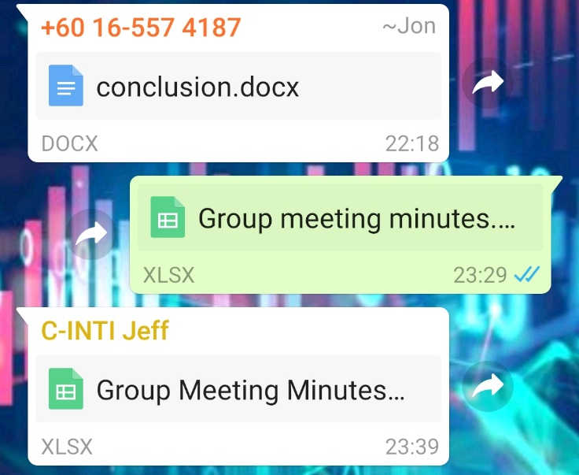  - Helping the team to provide & elaborate points – As the top of part of individual reflection that I provided, I’ve involved in doing Food Log.  - The quality of work of GTP2 – Good quality of work that is ensured by Mr. Ihsan during draft check.  - Provide screenshots of the announcement  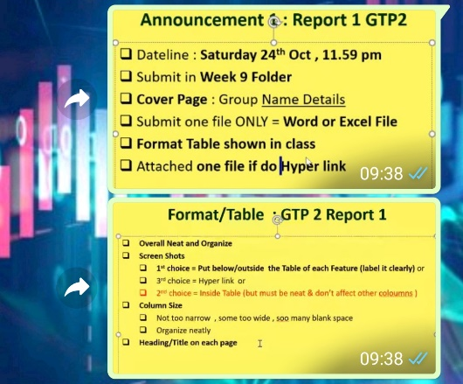  - Review the ideas
4. Next time: (write what you would do differently next time). | GTP2 :  - Provides more creative ideas – to help the group to score higher marks  - Improve the quality of the group project – I’ll make sure that what I do for my parts is forcing the lecturers to give full marks.  - Time management – I’ll manage my time efficiently so that it is enough time for me to provide good quality of points.  - Do things smartly – I’ll make sure to follow the tips and instructions provided by the lecturers before started to do the project.
5. How could your lecturer change this project to make it better next time? | GTP2 :  - Mr Ihsan should announce the reminder for due date of each task  - Lecturer should delegate more time to give comments on every draft check of every group so that each group can makes better changes earlier.  - Mr Ihsan should make sure the due date of each task is accurate as announced during the class.
GTP3
INDIVIDUAL /SELF REFLECTION REPORT (5%) & PEER REVIEW (5%)
ON EMPLOYER PROJECT WITH BOOK DOC

Think about what you did in this project (your tasks and responsibilities), and how well did the project went for your team.
Write your reflection in the right column.
1000-1200 words
PART A: SELF REFLECTION
Fill up your Answer INSIDE the below Table/Template
Student Name: | Yap Aik Shen
Student ID: | J19029478
Section : | DB5
Group/Team Name: | The Optimizers 2.0
Role in Team : | Secretary
All the evidences of the points of Individual reflection & peer review are provided here :

https://docs.google.com/document/d/1BJbrtrVCNIXVWQVQHsKjcJQymtt9ZCVK8MAtIAuzU6g/edit?usp=sharing
List the Part (s) you in charge of : | GTP3 :  1) Retention part of Twitter  2) Presentation slides designation for Twitter GTP3
About Myself: | Explain and provide evidence
1. What personal strengths / weaknesses of mine did this project reveal? | GTP3 :  - Cooperative (strength)– being cooperative with the group members to do my works on time  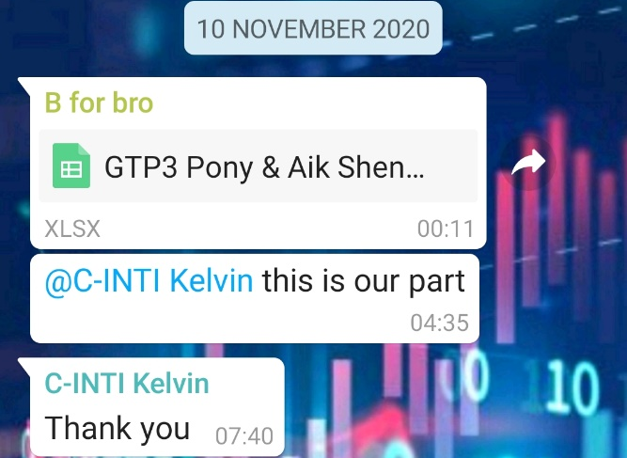  - Time management (weakness)– I did not utilize my time efficiently as there are a lot of other assignments.  - Lack of confidence (weakness)- It took me more time to finish the task as I were not confident enough about the points written.  - Too relax (weakness)- I started to do the task around the due date.
2. How did my strengths or weaknesses affect the task that was given to me, positively and negatively? | GTP3 :  - Cooperative – positively increase my working efficiency  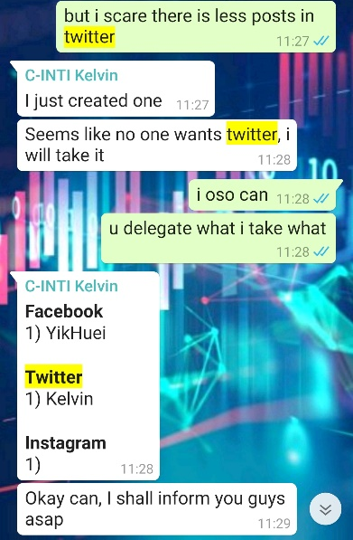  - Time management – negatively affect my work as I did not utilize the time efficiently.  - Lack of confidence affects the task that was given to me negatively as it takes me more time to do an easy task.
3. What can I do to build about my strength and overcome my weaknesses? | GTP3 :  - Cooperative – take note on what lecturer and group leader advises on dateline of each task  - Time management – do a time schedule for the work and avoid last minute works.  - Lack of confidence – find confidence through motivation videos
4. What did I experience in terms of difficulty working/ interacting with other people? | GTP3 :  - Communication – we were having virtual communication such as virtual meeting which is not that efficient  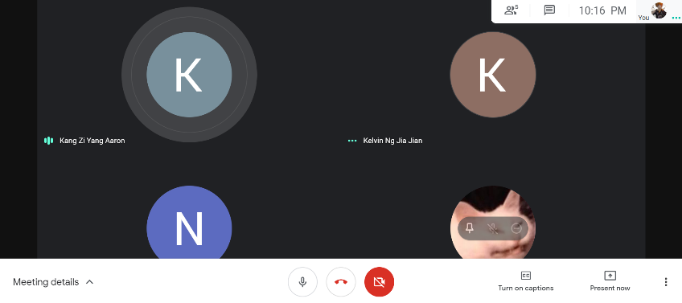  - Cooperation – there would be sometime when the group members did not aware about the notification of the task  - Arguments on ideas – we have a lot of ideas so it causes arguments when discussing
5. What can I do differently next time to minimize such difficulties? | GTP3 :  - Having more communication methods – I will try to have more communication methods with other group members  - Reminds earlier – I will try to remind the group members about the notification of date line.  - Review the ideas – review the ideas provided by the other group members
6. What personal skills did I use in handling my task? | GTP3 :  - Analytical skill – Find the Twitter posts of BookDoc and its competitors  - Hard skill – using Microsoft Word & Excel  - Problem solving skill – change and improve the points depends on lecturer’s checklist
7. What personal skills would I like to have had in order to have handled it better and how might I develop them? | GTP3 :  - Ability to work under pressure – I need to have the ability to complete my task on time while doing other assignments also  - Confidence – be confidence for the ideas  - Creativity – provide more creative suggestions for GTP3
About Project:
1. What I enjoyed: (write about what you liked most about the project) | GTP3 :  - Teamwork – we have instant virtual meetings to discuss and delegate the tasks clearly and every team member has performed well under the instructions given by the leader.  - Learning new things – Through the project, I have learned that how does employers do their posting on social media  - Find out business opportunities – Through the project, it gives me some creative business ideas to start my own business after graduating.  - Find out improvements of app – I’m enjoying to give some suggestions on improvements of keeping retention on Twitter so that it really helps BookDoc.
2. What I found difficult: (write about any part of the project you found hard to do.) | GTP3 :  - To provide creative suggestions- While doing GTP3, I found that it takes time to do research on finding creative suggestions to improve BookDoc retention on Twitter.  - Shortage of time – I feel rushed while doing the tasks of GTP3 as the time given by the lecturer was not so enough.  - Time-consuming – I found that finding and using the competitors apps are very time-consuming.  - Communication – Due to the covid-19 pandemic, we are doing capstone project through online class. So, it takes more time and times for us to discuss without seeing each others of the group members.
3. What really worked: (write about any part that you thought worked well). | GTP3 :  - As a secretary of the group, I have provided recordings of every group meeting including group meeting with lecturer. I believe this can really help the team members to revise of the important points and make improvement.  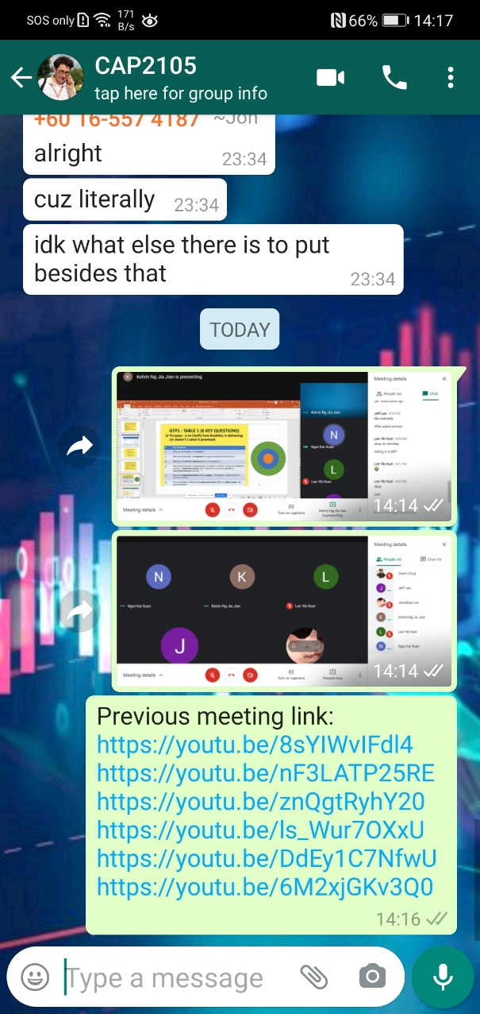  - As a secretary of the group, I’m doing my duty to edit & upload the Group Meeting Minutes to BB.  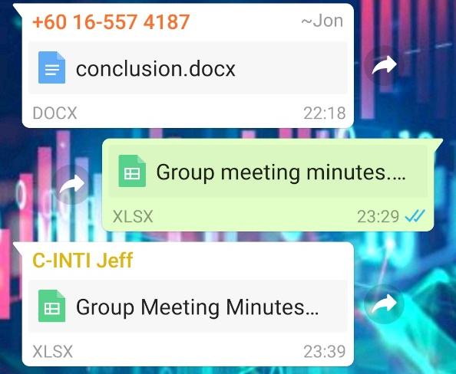  - Helping the team to provide & elaborate points – As the top of part of individual reflection that I provided, I’ve involved in doing Food Log.  - The quality of work of GTP3 – Good quality of work that is ensured by Mr. Ihsan during draft check.  - Provide screenshots of guideline  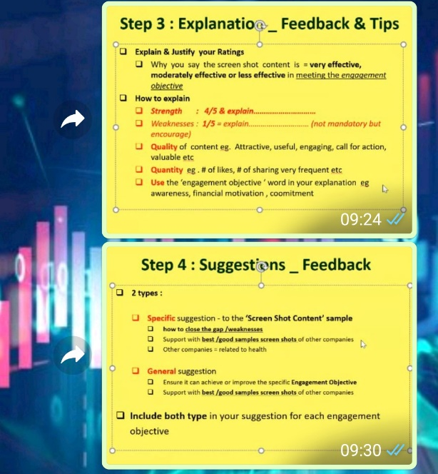
4. Next time: (write what you would do differently next time). | GTP3 :  - Provides more creative ideas – to help the group to score higher marks  - Improve the quality of the group project – I’ll make sure that what I do for my parts is forcing the lecturers to give full marks.  - Time management – I’ll manage my time efficiently so that it is enough time for me to provide good quality of points.  - Do things smartly – I’ll make sure to follow the tips and instructions provided by the lecturers before started to do the project.
5. How could your lecturer change this project to make it better next time? | GTP3 :  - Mr Ihsan should announce the reminder for due date of each task  - Lecturer should let us to do GTP3 using Microsoft word as Excel is inconvenient for typing works.  - Mr Ihsan should make sure the due date of each task is accurate as announced during the class.

Final Presentation
INDIVIDUAL /SELF REFLECTION REPORT (5%) & PEER REVIEW (5%)
ON EMPLOYER PROJECT WITH BOOK DOC

Think about what you did in this project (your tasks and responsibilities), and how well did the project went for your team.
Write your reflection in the right column.
1000-1200 words
PART A: SELF REFLECTION
Fill up your Answer INSIDE the below Table/Template
Student Name: | Yap Aik Shen
Student ID: | J19029478
Section : | DB5
Group/Team Name: | The Optimizers 2.0
Role in Team : | Secretary
All the evidences of the points of Individual reflection & peer review are provided here :

https://docs.google.com/document/d/1BJbrtrVCNIXVWQVQHsKjcJQymtt9ZCVK8MAtIAuzU6g/edit?usp=sharing
List the Part (s) you in charge of : | FINAL PRESENTATION :  1) Presentation slides designation for Twitter FINAL PRESENTATION
About Myself: | Explain and provide evidence
1. What personal strengths / weaknesses of mine did this project reveal? | FINAL PRESENTATION :  - Cooperative (strength)– being cooperative with the group members to do my works on time  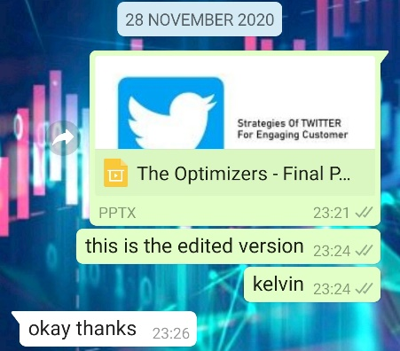  - Time management (weakness)– I did not utilize my time efficiently as there are a lot of other assignments.  - Lack of confidence (weakness)- It took me more time to finish the task as I were not confident enough about the points written.  - Too relax (weakness)- I started to do the task around the due date.
2. How did my strengths or weaknesses affect the task that was given to me, positively and negatively? | FINAL PRESENTATION :  - Cooperative – positively increase my working efficiency  - Time management – negatively affect my work as I did not utilize the time efficiently.  - Lack of confidence affects the task that was given to me negatively as it takes me more time to do an easy task.
3. What can I do to build about my strength and overcome my weaknesses? | FINAL PRESENTATION :  - Cooperative – take note on what lecturer and group leader advises on dateline of each task  - Time management – do a time schedule for the work and avoid last minute works.  - Lack of confidence – find confidence through motivation videos
4. What did I experience in terms of difficulty working/ interacting with other people? | FINAL PRESENTATION :  - Communication – we were having virtual communication such as virtual meeting which is not that efficient  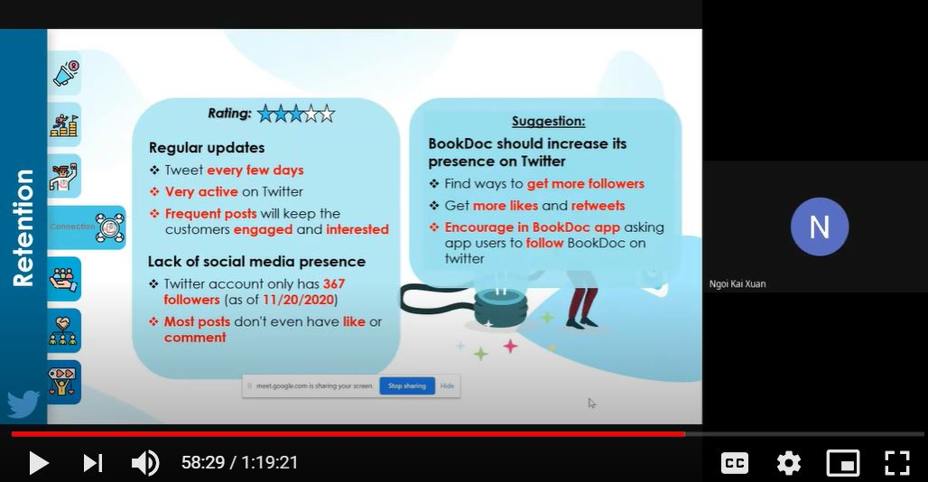  - Cooperation – there would be sometime when the group members did not aware about the notification of the task  - Arguments on ideas – we have a lot of ideas so it causes arguments when discussing
5. What can I do differently next time to minimize such difficulties? | FINAL PRESENTATION :  - Having more communication methods – I will try to have more communication methods with other group members  - Reminds earlier – I will try to remind the group members about the notification of date line.  - Review the ideas – review the ideas provided by the other group members
6. What personal skills did I use in handling my task? | FINAL PRESENTATION :  - Analytical skill – Find the Twitter posts of BookDoc and its competitors  - Hard skill – using Microsoft Word & Excel  - Problem solving skill – change and improve the points depends on lecturer’s checklist
7. What personal skills would I like to have had in order to have handled it better and how might I develop them? | FINAL PRESENTATION :  - Ability to work under pressure – I need to have the ability to complete my task on time while doing other assignments also  - Confidence – be confidence for the ideas  - Creativity – provide more creative suggestions for FINAL PRESENTATION
About Project:
1. What I enjoyed: (write about what you liked most about the project) | FINAL PRESENTATION :  - Teamwork – we have instant virtual meetings to discuss and delegate the tasks clearly and every team member has performed well under the instructions given by the leader.  - Learning new things – Through the project, I have learned that how does employers do their posting on social media  - Find out business opportunities – Through the project, it gives me some creative business ideas to start my own business after graduating.  - Find out improvements of app – I’m enjoying to give some suggestions on improvements of keeping retention on Twitter so that it really helps BookDoc.
2. What I found difficult: (write about any part of the project you found hard to do.) | FINAL PRESENTATION :  - To provide creative suggestions- While doing FINAL PRESENTATION, I found that it takes time to do research on finding creative suggestions to improve BookDoc retention on Twitter.  - Shortage of time – I feel rushed while doing the tasks of FINAL PRESENTATION as the time given by the lecturer was not so enough.  - Time-consuming – I found that finding and using the competitors apps are very time-consuming.  - Communication – Due to the covid-19 pandemic, we are doing capstone project through online class. So, it takes more time and times for us to discuss without seeing each others of the group members.  - Challenging – The presentation time is just 15 minutes for the whole GTP3, which is very challenging for us to shorten the points.
3. What really worked: (write about any part that you thought worked well). | FINAL PRESENTATION :  - As a secretary of the group, I have provided recordings of every group meeting including group meeting with lecturer. I believe this can really help the team members to revise of the important points and make improvement.  - As a secretary of the group, I’m doing my duty to edit & upload the Group Meeting Minutes to BB.  - Helping the team to provide & elaborate points – As the top of part of individual reflection that I provided, I’ve involved in doing Food Log.  - The quality of work of FINAL PRESENTATION – Good quality of work that is ensured by Mr. Ihsan during draft check.  - Upload screenshots of guidelines of slides  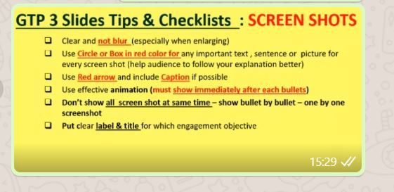  - Participating in rehearsal  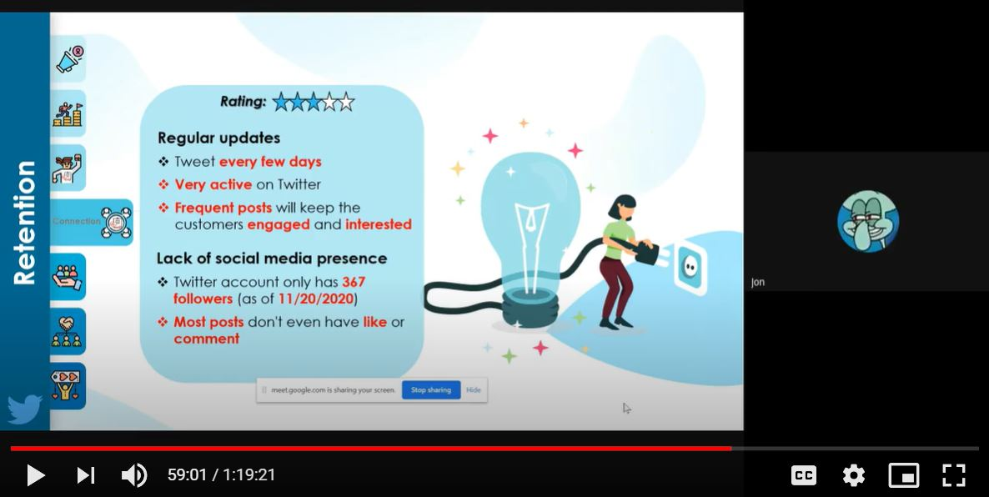
4. Next time: (write what you would do differently next time). | FINAL PRESENTATION :  - Provides more creative ideas – to help the group to score higher marks  - Improve the quality of the group project – I’ll make sure that what I do for my parts is forcing the lecturers to give full marks.  - Time management – I’ll manage my time efficiently so that it is enough time for me to provide good quality of points.  - Do things smartly – I’ll make sure to follow the tips and instructions provided by the lecturers before started to do the project.
5. How could your lecturer change this project to make it better next time? | FINAL PRESENTATION :  - Mr Ihsan should plan to give the presenter more time for presentation.  - For example, the lecturer of consumer behaviour gave 30 minutes for each group presentation  - Mr Ihsan should give us more time for doing the final presentation as I think that it was too rush.

PART B: PEER EVALUATION – Screenshot link (different link with individual reflection report): https://docs.google.com/document/d/1wBJdIqtlm7Gp4SSwz3Q4zxizIStW_GnheSDucupZ0B0/edit?usp=sharing
GTP1
Please rate yourself and your team members on the relative contributions made to for the LF Logistics project.

Your ratings will be confidential and anonymous.. BE HONEST ON THIS EVALUATION
In rating yourself and your team members, use a one-to-five-point scale, where:

1=really weak
2=below average
3=average
4=above average
5=superior

Add the scores to obtain a total score for yourself and the other group members.

For every rate, give your brief explanation / comment inside the table - why he/she received the score you given.

Descriptions: GTP1
No | Group members name | 1.  On time for all group meetings  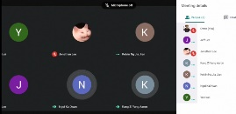 | 2.  Helped keep the group organized | 3. Provided number of useful ideas for the groups | 4.  Quality of work done for the group | 5.  Quantity of work done for the group | Total marks
1 | Kelvin Ng Jia Jian | 5  -Present and on time for all meetings | 5  - planning & creating for every meeting  - write down the instructions of task in Whatsapp.  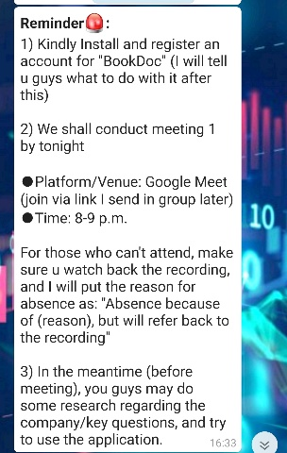  -help to answer questions of other group members | 5  -During the group meeting, Kelvin was active to provide ideas. | 5  -good quality of work that is ensured by Mr. Ihsan  -Read-friendly  -Professional | 5  - Involved in doing Q4,5,6  -Involved in finalizing GTP1  -Involved in creating templates for GTP1. | 25
2 | Lee Li Jie | 5  -Present and on time for all meetings | 5  -screenshot & upload the important slides  -help to answer questions of other group members | 5  -During the group meeting, Li Jie was active to provide ideas. | 5  -good quality of work that is ensured by Mr. Ihsan  -Read-friendly  -Professional | 5  - Involved in doing Q4,5,6  -Involved in finalizing GTP1  -Involved in creating templates for GTP1. | 25
3 | Lee Her Jun Jonathan | 5  -Present and on time for all meetings | 4  -reply message  -cooperate the time with team to make changes | 4.5  -Jonathan was active to provide ideas in Whatsapp group. | 5  -good quality of work that is ensured by Mr. Ihsan  -Read-friendly  -Professional | 5  Involved in doing Q5&6  (Q5 is hard). | 23.5
4 | Kang Zi Yang | 5  -Present and on time for all meetings | 4  -reply message  -cooperate the time with team to make changes | 5  - During the group meeting, Aaron was active to provide ideas. | 5  -good quality of work that is ensured by Mr. Ihsan  -Read-friendly  -Professional | 5  -Involved in doing Q3&6  (Q3 individually). | 24
5 | Ngoi Kai Xuan | 5  -Present and on time for all meetings | 5  -screenshot & upload the important slides  -reply message on time  - write down the instructions of task in Whatsapp. | 5  - During the group meeting, Kai Xuan was active to provide ideas. | 5  -good quality of work that is ensured by Mr. Ihsan  -Read-friendly  -Professional | 5  -Involved in doing Q1,2,5,6. | 25
6 | Lee Yik Huei | 5  -Present and on time for all meetings | 4.5  -reply message on time  -cooperate the time with team to make changes | 5  -During the group meeting, Yik Huei was active to provide ideas. | 5  -good quality of work that is ensured by Mr. Ihsan  -Read-friendly  -Professional | 5  -Involved in doing Q5&6  (Q5 is hard). | 24.5
7 | Yap Aik Shen | 5  -Present and on time for all meetings | 5  -screenshot & upload the important slides  -reply message on time  -cooperate the time with team to make changes | 4  - During the group meeting, Aik Shen was active to provide ideas. | 5  -good quality of work that is ensured by Mr. Ihsan  -Read-friendly  -Professional | 5  -Involved in doing Q1,2,5,6. | 24

Midpoint presentation
No | Group members name | 1.  On time for all group meetings | 2.  Helped keep the group organized | 3. Provided number of useful ideas for the groups | 4.  Quality of work done for the group | 5.  Quantity of work done for the group | Total marks
1 | Kelvin Ng Jia Jian | 5  -Present and on time for all meetings | 5  - planning & creating for every meeting  - write down the instructions of task in Whatsapp.  -help to answer questions of other group members | 5  -During the group meeting, Kelvin was active to provide ideas. | 5  -good quality of work that is ensured by Mr. Ihsan  -Read-friendly  -Professional | 5  -Involved in doing Q4 for the midpoint slides.  -Involved in finalizing midpoint slides | 25
2 | Lee Li Jie | 5  -Present and on time for all meetings | 5  -screenshot & upload the important slides  -help to answer questions of other group members | 5  -During the group meeting, Li Jie was active to provide ideas. | 5  -good quality of work that is ensured by Mr. Ihsan  -Read-friendly  -Professional | 5  -Involved in doing Q4 for the midpoint slides.  -Involved in finalizing midpoint slides | 25
3 | Lee Her Jun Jonathan | 5  -Present and on time for all meetings | 4.5  -reply message on time  -cooperate the time with team to do rehearsal | 5  -Jonathan was active to provide ideas in Whatsapp group.  -Jonathan was clear to shorten the presentation time by summarize the points | 5  -good quality of work that is ensured by Mr. Ihsan  -Read-friendly  -Professional | 5  -Involved in doing Q5 for the midpoint slides.  -presenter for the midpoint presentation | 24.5
4 | Kang Zi Yang | 5  -Present and on time for all meetings | 4.5  -reply message on time  -cooperate the time with team to do rehearsal | 5  -Aaron was active to provide ideas in Whatsapp group.  -Zi Yang was clear to shorten the presentation time by summarize the points | 5  -good quality of work that is ensured by Mr. Ihsan  -Read-friendly  -Professional | 5  -Involved in doing Q3 for the midpoint slides  -presenter for the midpoint presentation | 24.5
5 | Ngoi Kai Xuan | 5  -Present and on time for all meetings | 5  -screenshot & upload the important slides  -reply message on time  -cooperate the time with team tos make changes | 5  -During the group meeting, Kai Xuan was active to provide ideas. | 5  -good quality of work that is ensured by Mr. Ihsan  -Read-friendly  -Professional | 5  -Involved in doing Q1&2 for the midpoint slides  -mainly design the slides | 25
6 | Lee Yik Huei | 5  -Present and on time for all meetings | 4.5  -reply message on time  -cooperate the time with team to make changes | 5  -During the group meeting, Yik Huei was active to provide ideas. | 5  -good quality of work that is ensured by Mr. Ihsan  -Read-friendly  -Professional | 5  -Involved in doing Q5 for the midpoint slides  -video producer for the midpoint presentation | 24.5
7 | Yap Aik Shen | 5  -Present and on time for all meetings | 5  -screenshot & upload the important slides  -reply message on time  -cooperate the time with team to make changes | 5  - During the group meeting, Aik Shen was active to provide ideas. | 5  -good quality of work that is ensured by Mr. Ihsan  -Read-friendly  -Professional | 4  -Involved in doing contents of Q1&2 of presentation slides. | 24

GTP2
No | Group members name | 1.  On time for all group meetings | 2.  Helped keep the group organized | 3. Provided number of useful ideas for the groups | 4.  Quality of work done for the group | 5.  Quantity of work done for the group | Total marks
1 | Kelvin Ng Jia Jian | 5  -Present and on time for all meetings | 5  - planning & creating for every meeting  - write down the instructions of task in Whatsapp.  -help to answer questions of other group members | 5  -During the group meeting, Kelvin was active to provide ideas. | 5  -good quality of work that is ensured by Mr. Ihsan  -Read-friendly  -Professional | 5  Involved in doing GoActiv and Tele-consult  -Involved in finalizing GTP2  -Involved in creating templates for GTP2. | 25
2 | Lee Li Jie | 5  -Present and on time for all meetings | 5  -screenshot & upload the important slides  -help to answer questions of other group members | 5  -During the group meeting, Li Jie was active to provide ideas. | 5  -good quality of work that is ensured by Mr. Ihsan  -Read-friendly  -Professional | 5  - Involved in doing Food Log and GoActiv  -Involved in finalizing GTP2 | 25
3 | Lee Her Jun Jonathan | 5  -Present and on time for all meetings | 4.5  -reply message on time  -cooperate the time with team to make changes | 4.5  -Jonathan was active to provide ideas in Whatsapp group. | 5  -good quality of work that is ensured by Mr. Ihsan  -Read-friendly  -Professional | 5  Involved in doing Tele-consult | 24
4 | Kang Zi Yang | 5  -Present and on time for all meetings | 4.5  -reply message on time  -cooperate the time with team to make changes | 4.5  -Aaron was active to provide ideas in Whatsapp group. | 5  -good quality of work that is ensured by Mr. Ihsan  -Read-friendly  -Professional | 5  -Involved in doing Event & news | 24
5 | Ngoi Kai Xuan | 5  -Present and on time for all meetings | 5  -screenshot & upload the important slides  -reply message on time  - write down the instructions of task in Whatsapp. | 5  -During the group meeting, Kai Xuan was active to provide ideas. | 5  -good quality of work that is ensured by Mr. Ihsan  -Read-friendly  -Professional | 5  -Involved in doing Search & book independently | 25
6 | Lee Yik Huei | 5  -Present and on time for all meetings | 4.5  -reply message on time  -cooperate the time with team to make changes | 4.5  -During the group meeting, Yik Huei was active to provide ideas. | 5  -good quality of work that is ensured by Mr. Ihsan  -Read-friendly  -Professional | 5  -Involved in doing Event & news | 24
7 | Yap Aik Shen | 5  -Present and on time for all meetings | 5  -screenshot & upload the important slides  -reply message on time  -cooperate the time with team to make changes | 4  - During the group meeting, Aik Shen was active to provide ideas. | 5  -good quality of work that is ensured by Mr. Ihsan  -Read-friendly  -Professional | 5  -Involved in doing FoodLog feature | 24

GTP3
No | Group members name | 1.  On time for all group meetings | 2.  Helped keep the group organized | 3. Provided number of useful ideas for the groups | 4.  Quality of work done for the group | 5.  Quantity of work done for the group | Total marks
1 | Kelvin Ng Jia Jian | 5  -Present and on time for all meetings | 5  - planning & creating for every meeting  - write down the instructions of task in Whatsapp.  -help to answer questions of other group members | 5  -During the group meeting, Kelvin was active to provide ideas. | 5  -good quality of work that is ensured by Mr. Ihsan  -Read-friendly  -Professional | 5  Involved in doing Instagram  And Acquisition of Twitter  -Involved in finalizing GTP3  -Involved in creating templates for GTP3. | 25
2 | Lee Li Jie | 5  -Present and on time for all meetings | 5  -screenshot & upload the important slides  -help to answer questions of other group members | 5  -During the group meeting, Li Jie was active to provide ideas. | 5  -good quality of work that is ensured by Mr. Ihsan  -Read-friendly  -Professional | 5  - Involved in doing Facebook  -Involved in finalizing GTP3 | 25
3 | Lee Her Jun Jonathan | 5  -Present and on time for all meetings | 4.5  -reply message on time  -cooperate the time with team to make changes | 4.5  -Jonathan was active to provide ideas in Whatsapp group. | 5  -good quality of work that is ensured by Mr. Ihsan  -Read-friendly  -Professional | 4  Involved in doing Presentation for GTP3 | 23
4 | Kang Zi Yang | 5  -Present and on time for all meetings | 4.5  -reply message on time  -cooperate the time with team to make changes | 4.5  -Aaron was active to provide ideas in Whatsapp group. | 5  -good quality of work that is ensured by Mr. Ihsan  -Read-friendly  -Professional | 4  -Involved in doing Presentation for GTP3 | 23
5 | Ngoi Kai Xuan | 5  -Present and on time for all meetings | 5  -screenshot & upload the important slides  -reply message on time  - write down the instructions of task in Whatsapp. | 5  -During the group meeting, Kai Xuan was active to provide ideas. | 5  -good quality of work that is ensured by Mr. Ihsan  -Read-friendly  -Professional | 5  -Involved in doing Retention of Twitter | 25
6 | Lee Yik Huei | 5  -Present and on time for all meetings | 4.5  -reply message on time  -cooperate the time with team to make changes | 4.5  -During the group meeting, Yik Huei was active to provide ideas. | 5  -good quality of work that is ensured by Mr. Ihsan  -Read-friendly  -Professional | 5  -Involved in doing Facebook | 24
7 | Yap Aik Shen | 5  -Present and on time for all meetings | 5  -screenshot & upload the important slides  -reply message on time  -cooperate the time with team to make changes | 4  - During the group meeting, Aik Shen was active to provide ideas. | 5  -good quality of work that is ensured by Mr. Ihsan  -Read-friendly  -Professional | 4.5  -Involved in doing screenshots & contents of Twitter | 23.5

Final Presentation
No | Group members name | 1.  On time for all group meetings | 2.  Helped keep the group organized | 3. Provided number of useful ideas for the groups | 4.  Quality of work done for the group | 5.  Quantity of work done for the group | Total marks
1 | Kelvin Ng Jia Jian | 5  -Present and on time for all meetings | 5  - planning & creating for every meeting  - write down the instructions of task in Whatsapp.  -help to answer questions of other group members | 5  -During the group meeting, Kelvin was active to provide ideas. | 5  -good quality of work that is ensured by Mr. Ihsan  -Read-friendly  -Professional | 5  -Involved in doing Instagram  And Acquisition of Twitter  -Involved in finalizing FINAL PRESENTATION  -Involved in creating templates for FINAL PRESENTATION. | 25
2 | Lee Li Jie | 5  -Present and on time for all meetings | 5  -screenshot & upload the important slides  -help to answer questions of other group members | 5  -During the group meeting, Li Jie was active to provide ideas. | 5  -good quality of work that is ensured by Mr. Ihsan  -Read-friendly  -Professional | 5  - Involved in doing Facebook  -Involved in finalizing FINAL PRESENTATION | 25
3 | Lee Her Jun Jonathan | 5  -Present and on time for all meetings | 4.5  -reply message on time  -cooperate the time with team to do rehearsal | 5  -Jonathan was active to provide ideas in Whatsapp group.  -Jonathan was clear to shorten the presentation time by summarize the points | 5  -good quality of work that is ensured by Mr. Ihsan  -Read-friendly  -Professional | 5  -Involved in being the presenter for FINAL PRESENTATION | 24.5
4 | Kang Zi Yang | 5  -Present and on time for all meetings | 4.5  -reply message on time  -cooperate the time with team to do rehearsal | 5  -Aaron was active to provide ideas in Whatsapp group.  -Zi Yang was clear to shorten the presentation time by summarize the points | 5  -good quality of work that is ensured by Mr. Ihsan  -Read-friendly  -Professional | 5  -Involved in being the presenter for FINAL PRESENTATION | 24.5
5 | Ngoi Kai Xuan | 5  -Present and on time for all meetings | 5  -screenshot & upload the important slides  -reply message on time  -cooperate the time with team to do rehearsal | 5  -During the group meeting, Kai Xuan was active to provide ideas. | 5  -good quality of work that is ensured by Mr. Ihsan  -Read-friendly  -Professional | 5  -Involved in doing presentation slides of Twitter | 24
6 | Lee Yik Huei | 5  -Present and on time for all meetings | 4.5  -reply message on time  -cooperate the time with team to do rehearsal | 5  -During the group meeting, Yik Huei was active to provide ideas. | 5  -good quality of work that is ensured by Mr. Ihsan  -Read-friendly  -Professional | 4  -Involved in doing presentation slides of Facebook | 23.5
7 | Yap Aik Shen | 5  -Present and on time for all meetings | 5  -screenshot & upload the important slides  -reply message on time  -cooperate the time with team to do rehearsal | 5  - During the group meeting, Aik Shen was active to provide ideas. | 5  -good quality of work that is ensured by Mr. Ihsan  -Read-friendly  -Professional | 4  -Involved in doing presentation slides of Twitter | 24

